**Practical:9**

**Aim: Case study ERP and E-Business.**

**Introduction**

* E-business has changed the definition of enterprise systems. ERP focuses on core business functions, while E-business pushes the ERP from inside core of the organizations to the network edge.
* By making use of E-business approaches, organizations can have the ERP integration benefits of flexibility, reduction in cost, more effective and quick responses etc.
* By integrating ERP with E-business, a new extended ERP system emerges that creates business which is more lively, more focused and highly competitive than traditionally structured business.
* By using Internet and WWW services, organizations are implementing PDM(Product Data Management),SCM (Supply-Chain Management) and CRM(Customer-Relation-Management capabilities.
* These systems enable companies to link their operations seamlessly with customers and suppliers.

**E-Business:**

* The definition of E-Business is ‘an enterprise designed for success in the Information Economy.
* E-Business brings into play an organization’s resources and partners in new and innovative ways to create clear strategic advantage.
* The potential of E-Business goes far beyond new technologies – to impact and engage all aspects of a business – strategy, process, organization, and systems – to extend the business beyond its own boundaries – where there are no boundaries...’

**E-Business and ERP: Bringing two Paradigms together:**

**Benefits derived from ERP Implementations:**

Main benefits derived from ERP implementation include:

* Bringing people and processes which traditionally were physically and/or logically separated together in a collaborative environment.
* Replacing inventory with information by being able to produce more accurate forecasts.
* Relieving users from routine tasks and freeing them up to focus on value adding activities.
* Standardizing of business processes across the enterprise on a global basis.
* Centralized control of system configuration and master data ensuring data integrity.

**Benefits derived from E-Business Implementations:**

The reasons why companies in all sectors of the economy are embarking on E-Business projects is the need to derive benefits attributed to E-Business which are necessary to stay ahead or at least keep abreast with competitors in an increasing fast-paced environment.

Those benefits are

* Gathering information about customers that will enable the business to anticipate and satisfy customer’s needs.
* Increasing customer loyalty by focusing on customer relationship management across the entire life cycle, using techniques such as real-time dynamically customizable web-pages created from self-generated preference profiles.
* Establishing a global reach to customers and suppliers, cutting purchasing costs and broadening market share.
* Reducing dramatically the costs of transactions with business partners (customers and suppliers).
* Reducing dramatically the time it takes to complete a transaction with a business partner.
* Easy sharing of information with business partners, thus reducing the need for high inventory levels.
* Enabling collaboration between business partners to work jointly on solutions/products for the marketplace, reducing cycle-time.

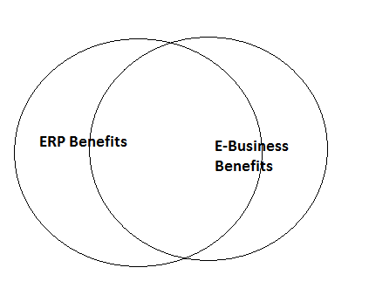

Fig: Benefits overlap between ERP system and E-Business Application.

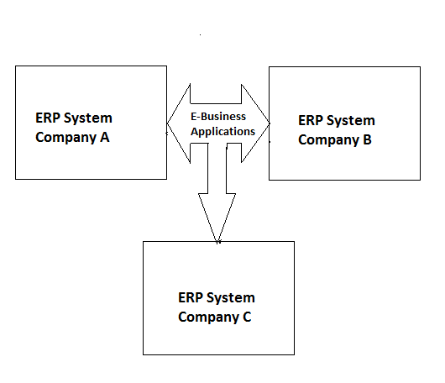

Fig: E-Business Applications supported by ERP systems

**Aligning business processes, people, technology and organization between**

**ERP and E-Business:**

* To make an E-Business implementation successful, it must be aligned with the ERP foundation on which is being build.
* It is more than likely that adjustments to the strategy, processes and technology, which support the ERP system and vice versa will be necessary so they can meet the needs of E-Business.

**Business Process:**

* E-Business will enhance existing value chain to cross company boundaries in many ways.
* For example, in the procurement area, B2B procurement will streamline internal processes such as requisition approval and purchase order creation as well as external processes.
* Suppliers will be able to monitor inventory levels and improve their own ability to forecast, thus truly integrating themselves in the value chain.
* It is likely that some suppliers will emerge better equipped and willing to participate in this collaborative environment than others.



**People:**

* The emergence of E-Business as a new differentiating factor between companies changes the skill requirements for the both the people implementing E-Business solutions and those who are using the enhanced value chain.
* In terms of alignment of the skillsets required for ERP and E-Business implementation, it seems apparent that E-Business takes the enhancement of skills, which began with ERP implementations a step further.
* While in an ERP environment, the combination of technical skills and business knowledge is a strong advantage, it becomes a necessity in an E-Business environment.

**Technology:**

* Development and deployment never stops in the transition process to an E-Business environment.
* The pace of change affecting technology, competitive landscape and business model means that companies have to plan for more rapid life cycles for their E-Business applications than their ERP systems.
* This creates a problem for aligning the two platforms, which from a business prospective need to work seamlessly together.
* A trade-off between protection on the one hand and functionality, ease of use and performance will be the result and ownership and accountability needs to be established.

**COMMON ERP/E-BUSINESS PLATFORM (ORACLE & SAP)**

**SAP**

* SAP ERP is a world-class, fully integrated application that fulfills the core business needs of midsize companies and large organizations across all industries and market sectors.
* It helps enterprises to manage financials, human capital management, procurement, logistics, asset management, and corporate services.

**ORACLE**

* Today's ERP software needs to be scalable, affordable and easy to use. Oracle, the number one player in ERP, and the dominant supplier of relational database to the Windows NT and Unix market, became a leading independent software company worldwide.
* Oracle’s Internet Platform provides a comprehensive solution for ERP integration. Based on the popular hub-spoke-adapter architecture, Oracle uses XML to extract information from legacy and ERP applications.
* The information will be renderable through “Port lets” on the desired site. NDS Systems has met this challenge by creating Oracle-based ERP applications for small to mid-sized organizations in the manufacturing, distribution and fulfillment industries.

**Commonalities and Differences between ERP and E-Business Implementations**

* While many of the benefits derived from ERP and E-Business implementations are similar or even identical, the nature of those implementations is quite different

.

* To achieve the maximum level of benefits from both, it is important to understand from the outset what the commonalities and the differences between them are.

**Commonalities between ERP and E-Business Implementations**

* Both E-Business and ERP implementations are undertaken with similar strategic goals in mind.
* They both need to be part of the same enterprise-wide strategy to be successful because they have an impact on almost every business process, spanning financial management, Order-to-Cash, Production Planning and Logistics and Requisition-to-Cash process chains.
* In many cases, both implementations need to interact with the same external partners, such as suppliers and customers since traditional communication channels such as EDI will co-exists with E-Business communication over the Internet.

**ERP and E-business Example:**

I would like to give you a general order fulfillment work flow of an eCommerce company here:

**Step1-Order Download in OMS:** Order is placed by the customer from the front-end (web store) which is then downloaded into an order management system (OMS). This OMS can be a part of your web-store or it can be a back-end Enterprise system where the customer order gets downloaded.  
  
**Step2-Inventory Allocation:** As soon as the order flows into an OMS, the inventory from the Warehouse gets allocated to the order quantity. Thus the free quantity of that particular SKU(product) is decreased by the order quantity.   
  
**Step3-Order Picking:**The operations/fulfillment team then starts processing the order in the warehouse. First a pick list is generated against that order (usually its for multiple orders at one go and using wave management) and is handed over to a picker in the warehouse to pick that SKU from the bin/rack (in a zone). The picker picks that SKU from the location mentioned in the picklist and bring it back to the picking station (a stage location)  
  
**Step4-Order Packing and generation of labels:** After the picking is done, the next stage is packing. At the time of packing required documents are printed that needs to be send along with the shipment package to the customer. The order is then packed in a packing box and reports like Invoice, Shipping label are printed and kept along with the shipment.  
  
**Step5-Order shipment:**After the order is packed, it needs to be shipped out to the customer. The order gets assigned with the courier as per the shipping location (usually either at the time of order placement or at the time of packing) and a manifest is generated. Then the shipment is handed over to the courier guy who comes to the warehouse to pick up the shipment. Once the shipment is out of the warehouse the inventory gets reduced in the system.  
  
**Step6-Shipment Delivered:** The shipment then gets delivered to the respected customer and the courier company updates the delivery details back to the company whose consignment it was shipping. There can also be the case of customer return or return to origin due to customer unavailability which I am not discussing here.

Flowchart:

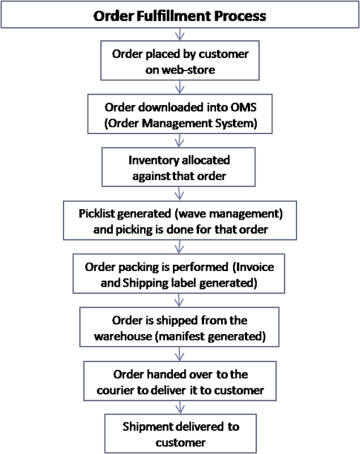

The scenario discussed above is an ideal scenario where the inventory is stocked in the Warehouse. There can be other 2-3 possibilities where the inventory is not stocked in the warehouse, such as:

**1. Back to back order fulfillment:**In this case the operations download the orders and ask its runner to go to the vendor immediately and pick up the required SKUs from the vendor and bring it back to the fulfillment center to fulfill the order.

**2. Drop shipment:** In this case the orders are downloaded and handed over to the vendor directly to fulfill the orders and ship it to the customers. The warehouse doesn't have any

control over this fulfillment.

**3. Made to order:** In this case, the orders are first taken from the customer and then the purchase order is raised to procure the SKUs of that order from the vendor. Once the SKUs are in the warehouse, the normal fulfillment cycle (as described above in detail) is followed to process the order.  
  
Flipkart usually does the stocking model or the back to back order fulfillment model.